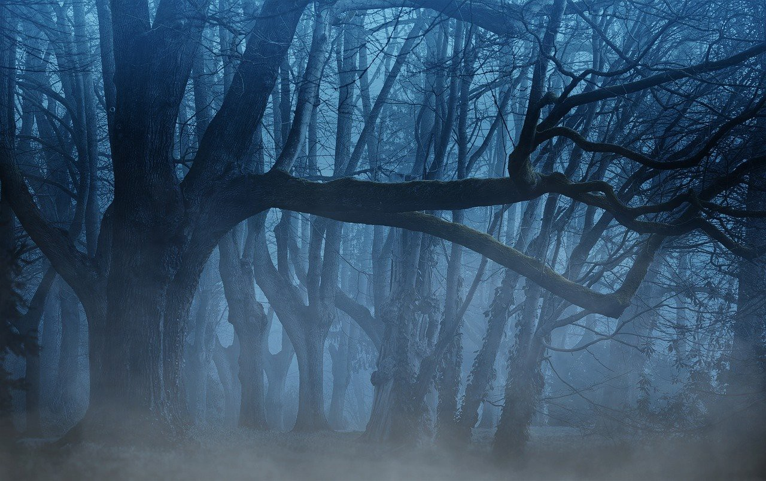  # | Name | Docker Image | Port(s) | Network | External Access | Authentication | Config Location
1 | Caddy | caddy:latest | 443, 8080 | caddy_network | YES | N/A | Caddyfile
2 | DuckDNS | lscr.io/linuxserver/duckdns | None | caddy_network | YES | Token | Env vars
3 | Docker Proxy | tecnativa/docker-socket-proxy | 2375 | bridge | YES | None | Socket proxy
4 | Vaultwarden | vaultwarden/server | 2026 | caddy_network | YES | Master Password | D:\Docker\Vaultwarden\
5 | Gitea | gitea/gitea | 5005, 2222 | multi | YES | SSH/Local | D:\Docker\Documentation\
6 | Frigate | ghcr.io/blakeblackshear/frigate:stable | 8004 | multi | YES | Optional | D:\Docker\Frigate\
7 | User-Homepage | custom:latest | 6330 | multi | YES | Network | D:\Docker\User Homepage\
8 | Homarr | ghcr.io/homarr-labs/homarr | 5000 | bridge | NO | Optional | Docker volume
9 | Dashy | lissy93/dashy | 4000 | bridge | NO | Optional | Docker volume
10 | Documentation-Homepage | ghcr.io/gethomepage/homepage | 1997 | bridge | NO | None | Docker volume
11 | ErsatzTV | jasongdove/ersatztv | 5001 | bridge | NO | None | Docker volume
12 | TVHeadend | linuxserver/tvheadend | 32402,32403 | bridge | NO | Credentials | Docker volume
13 | Threadfin | fyb3roptik/threadfin | 32401 | bridge | NO | Optional | Docker volume
14 | xTeVe | alturismo/xteve | 32773 | bridge | NO | None | Docker volume
15 | Audiobook Shelf | ghcr.io/advplyr/audiobookshelf | 32771 | bridge | NO | Local | Docker volume
16 | Komga | gotson/komga | 32769 | bridge | NO | Optional | Docker volume
17 | PhotoPrism | photoprism/photoprism | 32792 | bridge | NO | Credentials | Docker volume
18 | Immich Server | ghcr.io/immich-app/immich-server:v2 | 8002 | immich | NO | Local | Docker volume
19 | Immich PostgreSQL | ghcr.io/immich-app/postgres | 5432 | immich | NO | DB user | Docker volume
20 | Immich ML | ghcr.io/immich-app/immich-machine-learning:v2 | None | immich | NO | N/A | Docker volume
21 | Immich Redis | valkey/valkey:9 | 6379 | immich | NO | None | Docker volume
22 | Paperless-NGX | ghcr.io/paperless-ngx/paperless-ngx | 8000 | paperless | NO | Django | Docker volume
23 | Paperless PostgreSQL | postgres:16 | 5432 | paperless | NO | DB user | Docker volume
24 | Paperless Redis | redis:7 | 6379 | paperless | NO | None | Docker volume
25 | Archive Box | archivebox/archivebox | 8003 | archivebox | NO | Optional | Docker volume
26 | YouTube Downloader | nbr23/youtube-dl-server | 3005 | bridge | NO | None | Docker volume
27 | Bento PDF | bentopdf/bentopdf | 3002 | bridge | NO | None | Stateless
28 | IT Tools | corentinth/it-tools | 32777 | bridge | NO | None | Stateless
29 | Memos | ghcr.io/usememos/memos | 32783 | bridge | NO | Local | Docker volume
30 | Seekarr | tumeden/seekarr | 32784 | bridge | NO | Optional | Docker volume
31 | Dozzle | amir20/dozzle | 8001 | bridge | NO | Optional | Stateless
32 | Traefik | traefik | 3008 | bridge | NO | Optional | Docker volume
33 | Uptime Kuma | louislam/uptime-kuma:2.2.1 | 4001 | multi | NO | Admin | Docker volume
34 | Portainer | portainer/portainer-ce | 32775,32776 | bridge | NO | Local | Docker volume
35 | Netdata | netdata/netdata | 32791 | bridge | NO | None | Docker volume
36 | Pi-Hole | pihole/pihole | 53,67,123,32789,32790 | bridge | YES | Password | Docker volume
37 | Home Assistant | homeassistant/home-assistant | 32828 | bridge | NO | Local | Docker volume

